URINE PORPHYRINS
HOW TO TAKE THE SAMPLE

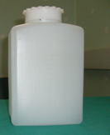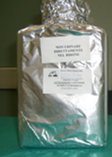
COVER WITH ALUMINIUM SHEET BEFORE YOU START TAKING THE SAMPLE
- Obtain a clean plastic container that holds at least 2 litres, sold in pharmacies.
URINE SAMPLES IN PLASTIC BOTTLES WILL NOT BE ACCEPTED
Before you start collecting the sample, you must cover the container with aluminium foil, including the top, to keep the urine away from light.
- In the morning of the day of sample collection, empty your bladder at the usual time (for example, 7:00 a.m.) This urine SHOULD NOT be collected.
From this time on, collect all subsequent urine, urinating directly into the container or by using a clean pot and transfer immediately.
- Continue collecting samples throughout the day and night. It is important to collect all the urine you produce.
- Store the container in the fridge for the rest of the day.
- The following morning, collect the last urine sample at the same time as the previous morning (e.g. 7:00 a.m., as above).
- For catheter users, cover the collection bag and connecting tube with aluminium foil and pour the urine into the container every 3 or 4 hours.

ON THE DAY OF DELIVERY OF THE 24-HOUR URINE SAMPLE, YOU MUST NOT UNDERGO OTHER URINE TESTS

