BENCE JON ES PROTEIN (BJ)

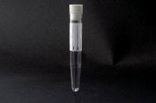
CONTAINER: 1 10ml vial

Collection: spontaneous sample; it is recommended to take the second morning sample (collected between 6:00 and 9:00 a.m.).

You can collect the sample from the Specimen Collection Centre .

Store in the fridge and return to the Specimen Collection Centre within 1 hour

