CALPROTECTIN

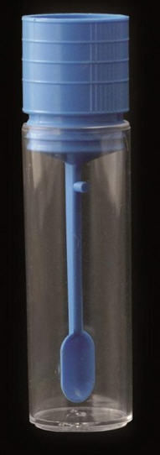 Specimen Container : Screw-top pot with spatula

How to collect a sample : Collect the stool sample using the spatula attached to the lid.
Caution : Do not overfill the specimen container. A sample the size of the spatula scoop
is sufficient.

Store in the fridge until you return the sample to the collection centre,
within 48 hours of taking it.

