DEOXYPYRIDINOLINE (PYRID )

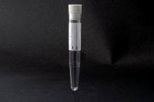
Container : 1 10ml vial

Time and method of collection: 2-hour urine collection The patient should discard the first morning urine, noting the time. After 1 hour, drink 200 ml of mineral water; after 1 additional hour (i.e. two hours after the first urination), collect the urine and return to the specimen collection clinic.

Store in the fridge and return to the Specimen Collection Centre within 1 hour

